Imaging Sub-surface Features of the Miami Circle with Ground Penetrating Radar

Jessie Pincus, Robert S. Carr, Dean Whitman

Ground Penetrating Radar (GPR) is a high-resolution near-surface geophysical technique that has proven to be useful for identifying archaeological remains non-invasively. While many GPR studies have been done, the results often consist only of anomaly maps, rather than identification of features. The Miami Circle has had a long history of documentation, offering an unusual opportunity for a reverse ground-truth study. By creating a catalog of GPR images of identified archaeological features, archaeologists entering the emerging sub-field of archaeogeophysics will be able to more easily identify sub-surface features at their own sites, making the possibility of GPR capability more useful.
This study investigates the Miami Circle, a 38-foot diameter circle on the bank of the Miami River in Miami, Florida. The Circle consists of postholes and basin-like features cut into the limestone bedrock and is a significant element in the understanding of prehistoric architectural features in southern Florida. In 1998 salvage archaeological investigations began here that led to the discovery, identification, excavation, and preservation of what is now understood to be the center of a Tequesta polity, ca A.D. 1-1000. A GPR study of the Miami Circle was conducted in 2004, following the protective covering of the site and is presented where shallow anomalies evident in GPR imaging could be directly correlated to their known archaeological counterparts. A combination of low and high frequency antennas was used for comparative studies for high-resolution imaging and analysis of the underlying geologic structure using 3D visualizations and animated depth views. A vital understanding of practicality and manueverability with GPR data was attained and is discussed.

Introduction
In 1998, salvage archaeological investigations began on the bank of the Miami River in Miami, Florida that led to the discovery, identification, excavation, and preservation of what is now understood to be the center of a Tequesta polity, ca A.D. 1-1000 (Carr, 2000). This 38-foot diameter circular feature has come to be known as the Miami Circle. The Circle consists of postholes and basin-like features cut into the limestone bedrock, possibly as support for a larger meeting hall type of structure and is a significant element in the understanding of prehistoric architectural structures in southern Florida.
Ground Penetrating Radar (GPR) is a high-resolution near-surface geophysical technique that has proven to be useful for identifying archaeological remains non-invasively (Conyers, 1998; Whiting, 2001). While many GPR studies have been completed, the results often consist only of anomaly maps, rather than identification of features. It is through ground-truth excavation that these anomalies become truly understood. Because the Miami Circle is a thoroughly documented site, it offers a rare opportunity for a reverse ground-truth study that compares the placement of anomalies in the GPR study with that of the known features of the archaeological site.
Following the protective covering and preservation of the site after excavation, a GPR study of the Miami Circle was conducted in the spring of 2004. Both high frequency (400 MHz) and low frequency (200 MHz) antennas from Geophysical Survey Systems, Inc. were used for comparative studies at the site. High-resolution imaging and analysis of the underlying geologic structure and archaeological features using 3D visualizations and animated depth-slice views has been proven to be a successful way to analyze GPR data (Conyers, 1997). The methodology used, results, and analysis will be discussed here where shallow anomalies evident in GPR imaging could be directly correlated to their known archaeological counterparts.
By creating a catalog of GPR images of identified archaeological features, archaeologists entering the emerging sub-field of archaeogeophysics will be able to more easily identify sub-surface features at their own sites, increasing the utility of GPR. In this paper we offer views of the solution hole and basin features, among others, evident in the GPR study that may be added to the archaeogeophysical record.

Methods
Survey design
The Miami Circle is only one part of the Brickell Point Site. Although there are other archaeological components of the site, it was decided the effort would be optimized if we focused only on imaging the basin and posthole features of the Miami Circle. With the help of Mr. T. L. Riggs, the professional land surveyor who was a co-discoverer of the site in 1998, we were able to mark a 20 x 20 meter square grid, centered on the Circle’s center point.
Data were collected with a GSSI Subsurface Interface Radar (SIR) System-2000 using both 200 and 400 MHz antennae. In general, increasing the antenna frequency results in greater resolved detail but less depth penetration. Data were collected as a series of parallel profiles, both in the north-south and east-west direction. For the low resolution, 200 MHz survey, lines were spaced at 1.0 meter intervals, with markers each meter. For the 400 MHz survey, lines were every 0.30 m with markers at 1.0 meter intervals. This survey design allowed for the construction of a 3-dimensional grid of GPR reflections.
To prevent wavering off course from the correct position within the grid during survey line acquisition, a guideline cord was placed along each line to guide the surveyor’s movement (see Figure 1: Guideline Cord). While it may seem trivial, our experience confirms this action to be key to accuracy in subsequent analysis.
GPR data was acquired over the course of four days in January, 2004. Survey lines for the 400 MHz study were completed in the first two days, with 200 MHz study lines being completed on the fourth day. Data acquisition went steadily throughout each day, pausing only for passing boats with radar that would interfere with the GPR signal.
From the beginning, the survey layout was designed from the archaeologist’s point of view. As has been seen in many archaeogeophysical studies (e.g. Conyers, 1998; Whiting, 2001; Nuzzo, 2002), accurate amplitude-slice maps were the goal for post-processing, and field acquisition mirrored that need resulting in a dense grid.
As mentioned above, the Circle was preserved and covered prior to the GPR survey. Each posthole and basin feature had been carefully filled with bags of pea gravel, followed by a layer of loose pea gravel, subsequently covered with a black tarp and quartz sand. This resulted in about a half meter of preservation material above the bedrock. We wanted to encompass the Circle feature in a large square, which resulted in a significant change in elevation along edge survey profile lines due to the presence of an excavation trench that runs west to east across the Circle (see Figure 2: Elevation Change). In addition, a large concrete footer rests in the SE corner, just north of a known solution hole.
Due to the changes in elevation, a follow up elevation survey using a Total Station instrument was undertaken to provide topographical information to enhance the GPR data. A dense grid of 441 elevation points was constructed, where data points were acquired throughout the grid area every square meter. These points were input by hand into each individually acquired GPR data line during post-processing.
For the high-resolution 0.30 m spacing of the 400 MHz grid, elevation points were taken into the grid program Surfer 7 and interpolated using a spline grid method. This resulted in 2,856 elevation data points that were respectively input ((68 lines x 21 elevation points) x 2 datasets). For the 1.00 m spacing of the 200 MHz grid, 882 elevation data points were input ((21 lines x 21 elevation points) x 2 datasets). Although significantly time consuming, the process of making sure elevations were correct throughout the survey, yielded tremendous benefits in terms of depth and spatial placement of features seen throughout the survey.
Processing
Much attention was paid to post-processing of the acquired data. Guidelines for filtering of the data were taken from many sources to see which would give the clearest and best results. A combination of the techniques described by Conyers and Goodman (1997), Conyers (1998), and Woodward et al. (2003) became the basis of post-processing methodology.
When acquiring GPR data, the air wave is the first waveform that arrives at the receiver from the transmitter (Woodward, 2003). This causes a delay for the first waveform that enters the sub-surface and so the 0-position must, and was, changed accordingly for each line. After 0-Position Correction, elevation points were input every meter along each line, followed by Surface Normalization, which corrects for topography by adjusting the vertical scale to the input elevations (RADAN, 2002). Individual partially-processed survey lines were then appended together to create the cross-grid respective 400 MHz and 200 MHz datasets (two datasets per survey). Reflections in the GPR data that may have been caused by local FM radio transmissions, cellular phone calls, radar from passing boats on the Miami River, and other environmental noise from the city were removed with a 100-750 MHz band-pass filter (Conyers, 1998). Any remaining background noise that was still present and seen as horizontal bands in the GPR data was filtered out revealing only the vertical reflections.
In order to correct time to depth in the GPR data, a modified time-depth analysis bar-test was completed in the field. A traditional bar-test is completed by pounding a metal bar into the side of an excavation at a known depth and dragging the antenna across this location to note its depth in nanoseconds (Conyers, 1997). This was not possible at the site and as a modification we buried a flat metal weight into the preservation sand of the Miami Circle at a known depth and then completed many short drags using both the 400 MHz and 200 MHz antennas over this point. This analysis determined a time-depth correction factor of 0.05 m/ns and 0.04 m/ns for each study, respectively. This correction factor was consistent with approximate velocity conversions commonly used for mineral/sandy soils and limestone (Davis, 1989; Vaughan, 1986).

Results
As mentioned above, the amplitude slice-map processing technique was the goal for primary analysis (Conyers, 1997). The two datasets for each survey were combined to form the final two “Super 3D” files that were used to visualize the features of the Miami Circle (RADAN, 2002). Animations of the movement through depth were created for each survey to aid in analysis and visualization of features.
The 200 MHz study shows GPR results from the surface to 4.10 m below the surface in 0.15 m increments, and can be seen at http://www.mnemotrix.com/geo/mcircle/mc200.gif. As was expected, the 200 MHz GPR study did not yield much in the way of archaeological features due to its low frequency and thus low resolution. Apparently, the preservation fill attenuated reflections from the sub-surface, well into the homogenous bedrock. Because the preservation fill was completely different than the soil layers that would have been present before excavation, there was a high degree of attenuation. This attenuation of reflections seemed to smear surface and near-surface reflections so that they appeared to extend below the water table, which is seen as a consistent horizontal reflection around 2.00 meter depth. In addition it was a much more coarse study, acquiring profile lines every meter, rather than every 0.30 m. All of the detailed archaeological analysis therefore came from the 400 MHz study and is discussed below.
From the high-resolution, archaeologically focused 400 MHz survey, two animated views of the GPR results were created. GPR results from the surface of the preserved Miami Circle to a depth of 0.675 m in 0.025 m increments (much like the 0.050 m archaeological levels of excavation) can be seen at http://www.mnemotrix.com/geo/mcircle/mc400_a.gif. A site plan overlay of the archaeological excavation units (surface to 0.600 m depth in 0.025 m increments) is superimposed on the GPR data to aid in analysis and can be seen at http://www.mnemotrix.com/geo/mcircle/mc400_b.gif (Carr, 2000). Excerpts of the latter animation are included in Figure 3: Animation Excerpts.
Through analysis we were able to answer many questions regarding archaeological features in the study area and how they are imaged in the GPR survey. The answers to these questions have archaeogeophysical application and are the objectives of this study.
First, can the black plastic tarp between the pea gravel and sand in the preservation fill be discerned? This feature is clearly seen as a coherent horizontal reflection in the 400 MHz data. At several points even undulations in the tarp were observed as depressions in the horizontal GPR reflections forming the boundary between the upper and lower levels of preservation fill. In addition, analysis of diffraction hyperbolas indicates that there was a velocity difference between the sand above the tarp and the gravel below. Velocities (m/ns) of the gravel layer were in keeping with that of limestone, although slightly faster due to the increase in air space (i.e. not solid limestone). The quartz sand above it exhibited characteristic velocities and high positive amplitudes.
Second, are there distinct signatures to look for in determining a posthole or basin feature in a GPR scan? Postholes were seen as strong hyperbolas about five to ten centimeters wide, just as described in excavation reports. Basin features were characterized by a larger, wider hyperbola (reflection) with two smaller ones demarcating the edges of the basin (see Figure 4: Basin-like Feature). A map showing where the example in Figure 4 is located within the surveyed area can be seen in Figure 5: Orientation Map. Throughout the survey we were able to see the bottoms of basin or posthole features about 60% of the time. The bottom was seen as a less robust reflection at the proper distance as recorded in excavations directly below the bedrock surface reflection of the feature. The reason for why sometimes the bottoms were visible and other times not is due to a combination of factors. Surface elevations for each line played a pivotal role, combined with whether a feature was located in an area with more or less fill. Areas that had less fill and were relatively flat yielded the best results in identifying basin and posthole features.
Third, we wanted to know how the basin holes are similar or different than the large solution feature in the SE quadrant in the GPR data (see Figure 5: Orientation Map for location within the surveyed area). Due to the large size of the solution hole (approximately four meters), and the fact that it is a geologic feature rather than a smaller archaeological feature, the solution hole is easily seen and can be traced through depth. Its bottom was clearly discernable and can be seen in Figure 6: Solution Hole Feature, about 3.40 m below the surface. Velocities were consistent with that of limestone, in addition to many reflections seen in a 2D view of the profile lines as we went further in depth. Another feature that was seen throughout the survey was that of the water table at 2.15 meters below the surface.
A high priority was assigned to the comparison between the placements of features recognized in the GPR survey to those of the excavation. Many features identified in the GPR data corresponded closely with the excavation features, except that they were slightly offset either to the SW or NE by about 0.30 m, and showed up at slightly different depths ranging from 0.30 m shallower than the excavation depth, to right on, or 0.30 m deeper. An example of this can be seen in Figure 7: Phenomenon of Offset. The complexity of exact placement is due to the fact that there were many issues in play, namely density of acquired GPR profile lines and elevation points, and will be discussed further below.

Conclusions – What We’ve Learned and Some Rules of Thumb
Probably the most important thing that we learned from this study was practicality and maneuverability in GPR data. As was mentioned earlier in this paper, when we began the survey, we knew data acquisition needed to be dense enough to image the archaeological features buried beneath the preservation fill. We also wanted to buffer the edges of the Circle with extra space in the grid so that the 38-foot feature would be clearly seen in the center and no posthole or basin features would be missed. This resulted in the 20 x 20 meter grid and significantly large data files to maneuver through.
The 0.30 m grid spacing for this GPR study yielded very good results which were all discussed in the previous section. One could argue that there is always “room for improvement” to gain a clearer view of the subsurface. An obvious assumption to make is that if GPR data acquisition had been collected at 0.15 m or even 0.05 m density, it would have yielded “better” results. However, this seems to not necessarily be the case. The resulting dataset files would have been so large and unwieldy that post-processing of the data would be an immense investment of time and energy, going beyond the bounds of practicality. Similarly, if GPR profile lines were at that density, elevation points would have also had to match that change. Post-processing would have been pushed even further beyond the practical allotment of time and resources which may be even generously assigned to a pre-excavation GPR survey in the real world.
If it were possible to improve upon the existing survey yet still be in the realm of feasibility, we might have acquired GPR data every 0.25 m rather than 0.30 m in the 400 MHz study, every 0.50 m rather than 1.00 m in the 200 MHz study, and recorded elevation data every 0.50 m rather than 1.00 m. In so doing, elevation points would not have required interpolation through a gridding program like Surfer to the same degree, and thus the placement of features might have been more precise. It is important to note however, that even with these slight increases in density, post-processing would still be quite intense, and sheer file size of the 3D data would be greatly taxing existing computer resources which we were already pushing to the limit.
Our study heartily confirmed Ground Penetrating Radar as a successful technology in the field of archaeology. When approaching a large area, it can be immensely clarifying and a needed tool. Small archaeological features can be imaged and located, given proper attention to resolution, detail, and data acquisition density. When conducting a pre-excavation GPR survey, the archaeogeophysicist, if able, should have an idea of the size of the features being looked for and a good understanding of the geological sediments in the area. If topography is highly variable, elevations should be taken at a practical density proportional to the density of the GPR grid lines. Above all, we confirmed that the better the working relationship with the Site Archaeologist, the better the results and the usefulness of the study.

Acknowledgements
The authors would like to thank the Mnemotrix Systems, Inc. team who supplied the GPR equipment and ongoing consultation and support for this project.
Figures

Figure 1: Guideline Cord
200 MHz data acquisition of the Miami Circle (looking NW). Notice the red guideline cord to the left of antenna for maintaining proper distance within the grid while acquiring GPR data.

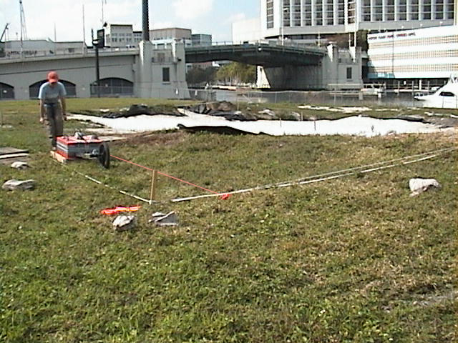

Figure 2: Elevation Change
Westerly view of the excavation trench at the Miami Circle that runs west to east. Due to this trench there were significant changes in elevation along edge survey profile lines.

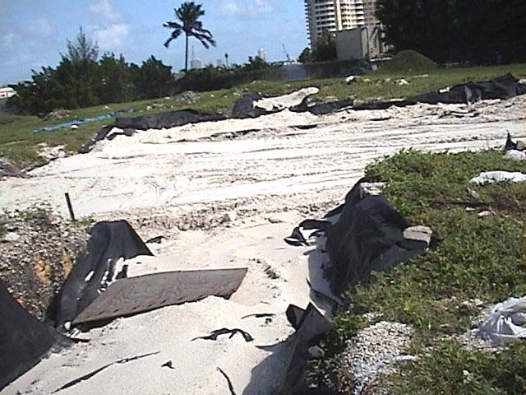

Figure 3: Animation Excerpts
Excerpts of animated GPR results from surface of preserved Miami Circle to 0.60 m depth. Full animation is available at http://www.mnemotrix.com/geo/mcircle/mc400_b.gif. To aid in analysis, gray site plan overlay of archaeological excavation units has been superimposed on the blue and green GPR data (Carr, 2000).

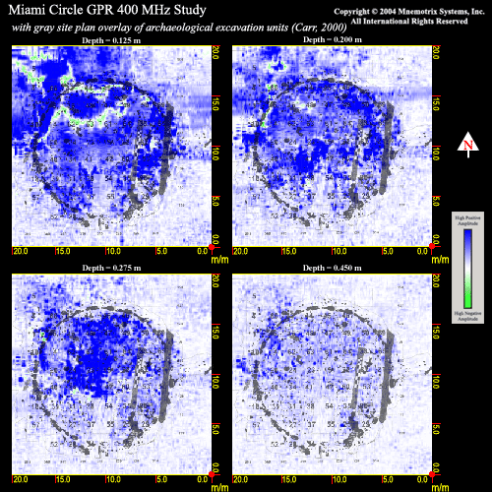

Figure 4: Basin-like Feature
Profile view (2D) of post and basin-like features in the 400 MHz Study. Basin-like features were characterized by a larger, wider hyperbola (reflection) with two smaller reflections demarcating the edges of the basin. Location of section is seen in Figure 5. Depth of basin edge reflections is ~ 0.45 m.

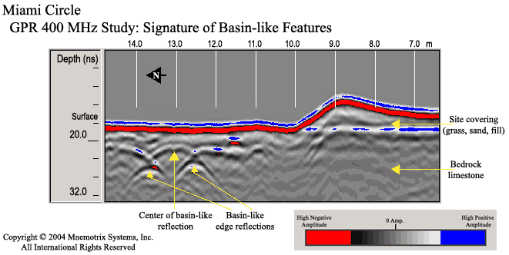
Figure 5: Orientation Map
Orientation map view of post and basin-like features (Figure 4) and solution hole (Figure 6) in the 400 MHz Study.

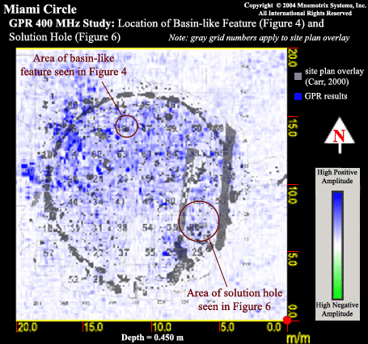

Figure 6: Solution Hole Feature
Profile view (2D) of solution hole in SE quadrant of Miami Circle. The solution hole has been outlined in a dashed yellow line. Due to its large size (about four meters), its bottom was evidenced as a strong reflection and is indicated as such at ~3.40 m depth. Solution hole outline averages ~2.00 m depth. Location of section within surveyed area can be seen in Figure 5.
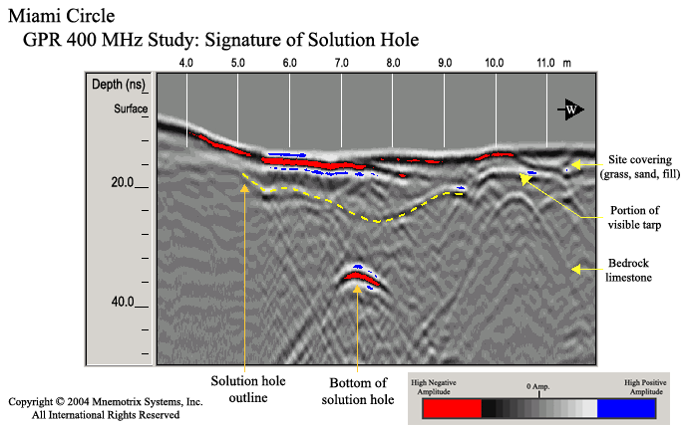

Figure 7: Phenomenon of Offset
Example of a distance offset between GPR features (in blue) and archaeological features (in gray). Many features identified in the GPR survey were mirrors of the same features found during excavation, but locations were offset sometimes either to the SW or NE by ~0.30 m, and sometimes showed up at slightly different depths.

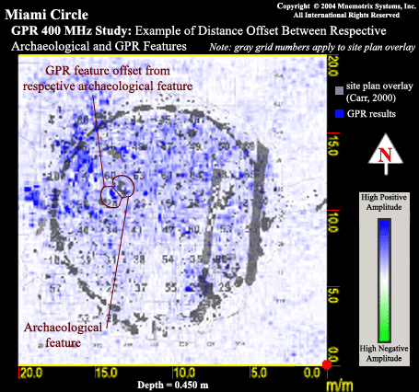
References

Carr, R. S., and Rickisack, J., 2000, Preliminary report on salvage archaeological investigations of the Brickell Point site (8DA12), including the Miami Circle: Florida Anthropological Society, Inc., Special Issue: The Miami Circle, 53: 260-284.

Conyers, L. B., Goodman, D., 1997. Ground-Penetrating Radar: An Introduction for Archaeologists. Altamira Press, Walnut Creek, 232 pp.

Conyers, L. B., and Cameron, C. M., 1998, Ground-Penetrating Radar Techniques and Three-Dimensional Computer Mapping in the American Southwest: Journal of Field Archaeology, 25: 417-430.

Davis, J.L., Annan, A.P. 1989. Ground penetrating radar for high-resolution mapping of soil and rock stratigraphy. Geophysical Prospecting, 37: 531-551.

Nuzzo, L., Leucci, G., Negri, S., Carrozzo, M. T., and Quarta, T., 2002, Application of 3D visualization techniques in the analysis of GPR data for archaeology: Annals of Geophysics, 45: 321-337.

RADAN for Windows NT, Version 4.0 User’s Manual, 2002. Geophysical Survey Systems, Inc., North Salem, 120 pp.

Vaughan, C.J. 1986. Ground-Penetrating Radar Surveys used in Archaeological Investigations. Geophysics 51: 595-604.

Whiting, B. M., McFarland, D. P., and Hackenberger, S., 2001, Three-dimensional GPR study of a prehistoric site in Barbados, West Indies: Journal of Applied Geophysics, 47: 217-226.

Woodward, J., Ashworth, P. J., Best, J. L., Sambrook, S., and Simpson, C. J., 2003, The use and application of GPR in sandy fluvial environments: methodological considerations. Eds., Bristow, C. S. and Jol, H. M. Ground Penetrating Radar in Sediments. Geological Society, London. Special Publications, 211: 127-142.

Jessie Pincus, Department of Earth Sciences, Florida International University
Robert S. Carr, Director Archaeological and Historical Conservancy of Florida
Dean Whitman, Department of Earth Sciences, Florida International University

