Ground Penetrating Radar Survey Report:

Follow-up Ground Truth Study

2005 Tell es-Safi/Gath Archaeological Project

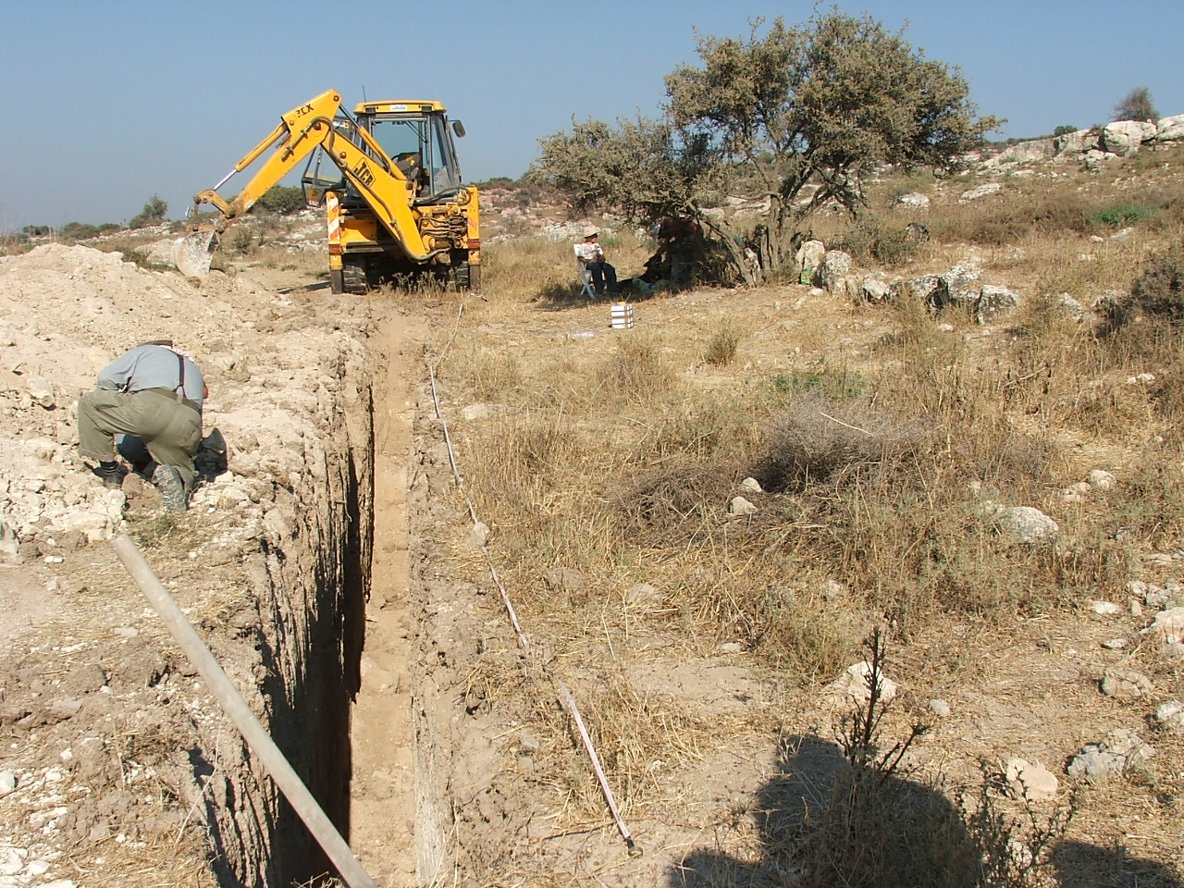

Figure 1: Tell es-Safi GPR ground-truth study.

Data Acquired August 4, 2005

Report compiled November 3, 2005

Survey and Report Published by Mnemotrix Systems, Inc.
Chief GPR Surveyor, Jessie Pincus Ben Avraham

Copyright © 2005 Mnemotrix Systems, Inc.
All International Rights Reserved
Introduction
During the summer of 2005 Mnemotrix Systems, Inc. continued its Ground Penetrating Radar (GPR) work at Tell es-Safi. The site of Tell es-Safi is one of great importance as it is what is now known by scholars as Philistine Gath, one of the five major cities of the Philistine civilization in ancient Israel (Ashkelon, Ashdod, Ekron, Gath [Tell es-Safi], and Gaza).
Work has focused primarily on locating the continuation of a siege trench dating to the mid-8th century BCE (Iron IIB) that circles much of the site on its eastern, southern, and western sides. The trench is unique as it is the only documented siege trench of its type in the region of Israel.
Ground Penetrating Radar is a non-invasive archaeogeophysical technique that helps to create what could be described as a sub-surface picture. In this way the technology can be used in pre-excavation planning to decide what location will give the most valuable archaeological results without first investing the resources necessary for actual excavation. Given the 40+ hectare size of this site, GPR has been included as a strategic method to allocate resources in an area too large to efficiently explore using only traditional excavation methods.
During 2005 the aim was to ground-truth through excavation a portion of the results from the previous 2004 season.

Background
On August 4, 2005, a backhoe was brought to the Tell es-Safi archaeological site. The Mnemotrix Team led the ground-truth study along with Aren Maeir, the Chief Archaeologist of the site, and Oren Ackermann, Geomorphologist of T. Safi.
The location of the principal work from the 2004 season is labeled in Figure 2 as “2004 GPR Area”. This area is located just north of Area C of the archaeological excavation. It was here in 2004 that we surveyed an area of about 75 square meters in 11 contiguous separately acquired grids of parallel GPR transects, as well as a 12th Control Study grid close to the already excavated trench in Area C6 (see Figure 3). These grids were put together into a Super-3D grid which covers the side of the hill sloping down towards the current cultivated fields to the north.
The details of our 2004 work can be read in the official report located at this online web address: http://www.mnemotrix.com/geo/essafi/trench/intro04.html .
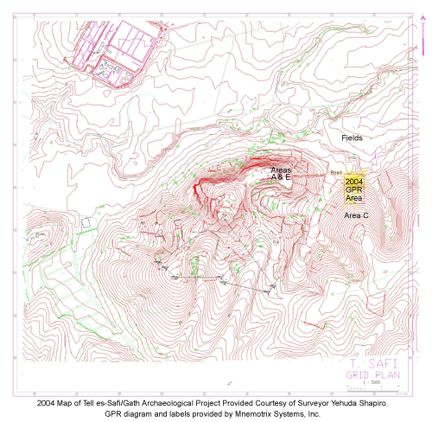
Figure 2: Bird’s eye view of Tell es-Safi and 2004 GPR work. A full-size version is available at: http://www.mnemotrix.com/geo/essafi/trench/zsite3.html.

The Trench Control Study was a survey of the excavated trench shown in Figure 3 as Grid 12. Grids 1-11 can be seen in Figures 3, 4, and 5, and show the areas surveyed where we were looking for a continuation of this siege trench.
After analyzing the 2004 data we were able to create an anomaly map whose purpose was to be used in the field and for future excavation planning at the site. This anomaly map was created by placing a black dot on the data wherever we found a significant anomaly that was similar to that of the anomalies we were seeing in the Trench Control Study. We used this data to compare anomalies that we saw throughout the 11 other grids to the anomalies that we knew to be related only to the trench.
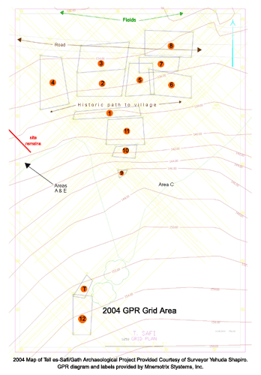
As is discussed in the 2004 report, what we believed to be the probable course of the trench and berm seemed to extend north from Area C downslope towards the fields. The probable course of the trench and berm are marked as a black line in Figure 4.
Figure 3: View of GPR Grids 1-11 and Grid 12 Trench Control Study next to excavated trench. Grids 1-11 explore the continuation of the siege trench.

2005 Actions Taken
During 2005 a 15 meter ground-truth trench was dug in an east-west direction to a depth of about 3 meters. This trench was just north of GPR Grid 1, centered in Grid 5, and extended partially into Grid 2.
We chose this location as it was perpendicular to the general trend of the anomalies heading north, and was between two points running N/S on the anomaly map. See Figure 5 for the relative location of the ground-truth trench and the schematic placement of the 11 grids.

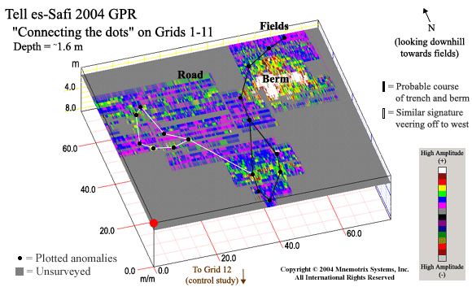
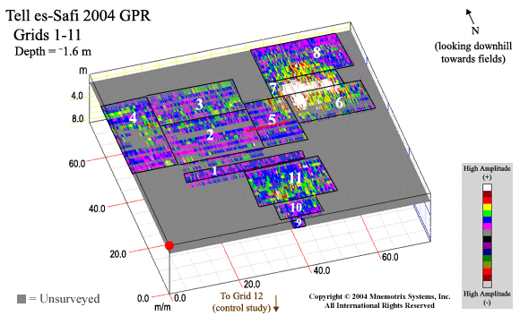
Figure 4: After studying the individual grids, we were able to plot the signatures labeled in each to trace the probable course of the trench and berm, shown by the black line. A similar signature veers off to the west, marked by a white line, which is not the subject of this study.
,
Figure 5: Schematic map of 2004 GPR Grids 1-11. Relative placement of ground-truth ditch is marked as a red horizontal line in Grids 5 and 2. This GPR Map can be seen in a GIS format with hotlinks to the relevant grid area GPR studies at:
http://www.mnemotrix.com/geo/essafi/trench/trench.html
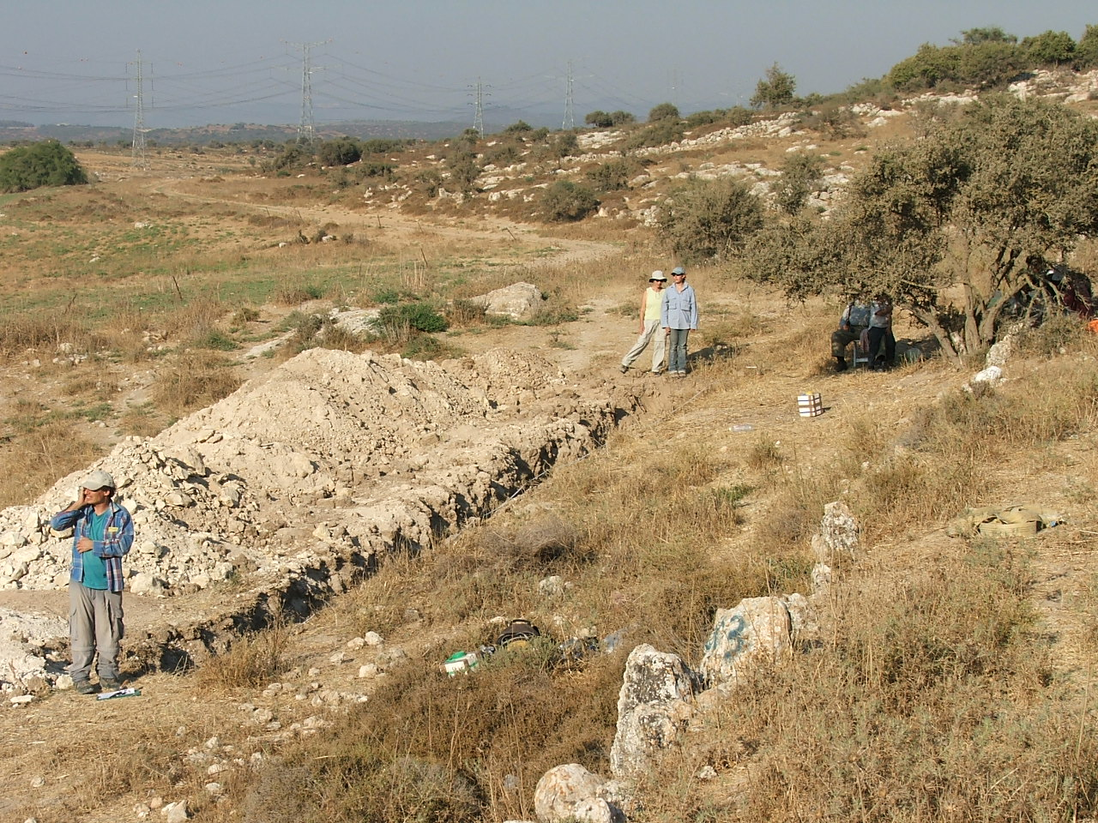
Figure 6 is a field picture of the ground-truth trench after it was dug on August 4, 2005. As the ground-truth ditch was dug, careful notes were made by the Mnemotrix Team along with Oren Ackerman. Each bucket of sub-surface material was put on a cloth to sift through before proceeding. In this way, some significant pottery was found and is being studied in follow-up research.
Figure 6: View, generally looking East, of dug ground-truth trench. Area is located just north of GPR 2004 Grid Area 1.

In-Field Results
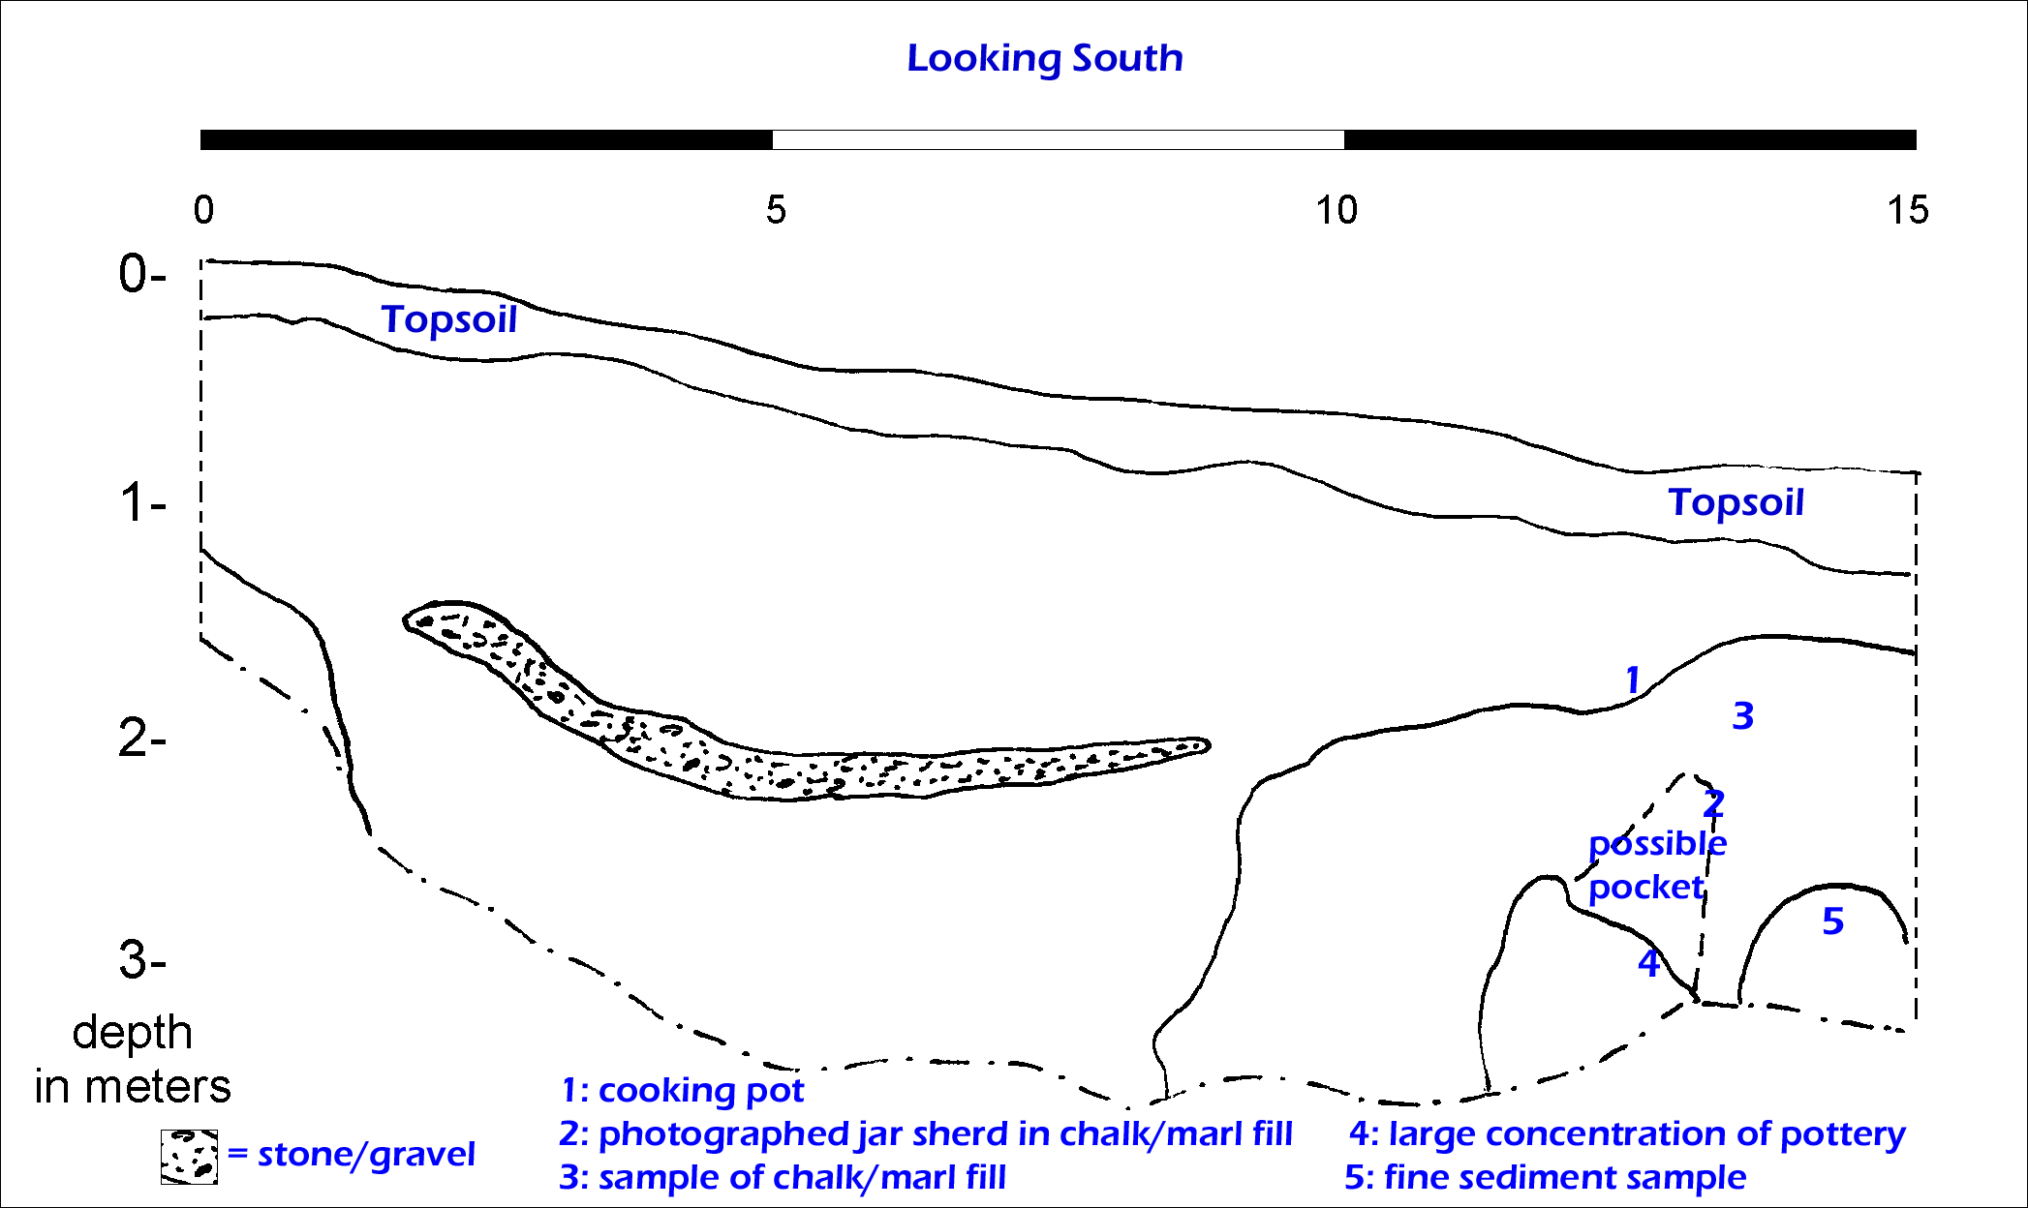
A profile of the ditch was drawn, which has been digitized and can be seen in Figure 7 below. As has been discussed, our goal of the day was to see if we could find some remnant of the siege trench. Thus we were looking for clues throughout the entire study.
Figure 7: Field profile of GPR ground-truth ditch provided by Oren Ackerman. Original field notes have been added by the Mnemotrix Team in blue.
In the first meter we crossed a sharp boundary from topsoil to the sub-surface layers which were seen at 90 cm. After this boundary large chunks of chalk, pebbles, hard (nari) limestone on top of soft (kirton) limestone, and bedrock were present. The chalk became very loose at this 90 cm depth. Figure 7 above is a field profile view of the trench.
In the second meter we encountered dense chalk bedrock, pieces of pottery, and chalk fragments with soil in between, in addition to loose material. There was a soil change at ~190 cm depth, which in the field seems to correlate to the depth of anomalies seen in the 2004 GPR study for this specific area. As we continued east at this depth we came upon more pottery. A large sherd was found between 190 to 220 cm depth and taken for future study.
In the third meter we found stones with many cut edges, too many to have been freshly made by the backhoe. What seemed the most surprising to us was that at a very deep level, more than 260 cm, we continued to find many sherds, very large chunks of chalk (42 cm wide), in addition a transition from kirton limestone to nari limestone.
Once the trench was dug we were able to climb inside and see what large features were available to be studied. Pottery was continuously found until our deepest point.
There are two main layers near the top – a gray alluvial layer with a browner layer below. Between these two is a layer of chalk, showing that erosion has occurred here. A prime clue that we could be in the siege trench would be a boundary line that cuts through the matrix or bedrock from the surface to deeper depths. As can be seen in Figure 7, there is a boundary between numbers 1 and 3 that continues to the lower depths. Large pebbles were found here that were similar to those found close to the GPR Trench Control Study. Some of these were taken as samples. This evidence suggests that we indeed may have found remnants of the siege trench.
It was understood at the time that if we were to be coming upon the siege trench then we would expect to see chalk fragments but the connections between them would be very loose. This is in fact what we were seeing. As we came closer to the end of the dug ditch it seemed that there was a clear possibility that we had indeed found part of the siege trench, based on the shape of the layering and the placement of the items found.
A significant amount of what we were seeing was fill. The question was where the fill was coming from. In the field it became clear that material rolled down the hill slope, making the area colluvial. We seemed to find a mixed layer of material, which means that the area at 2-3 meter depth was disturbed, rather than dormant. It is possible that because we were continuing to have finds at the lower levels perhaps the area in the past was at a lower elevation. This is something that we hope to resolve in the coming seasons of research.
Another point of interest was the presence of pockets of fine sediment that existed within the bedrock (number 5 in Figure 7) associated with many pieces of pottery at low depths. These may be suggestions of underground tunneling, although at the moment we are unsure of their true nature.
At the end of the day Aren Maeir came to the field to discuss the first results of the ground-truth study. His preliminary thoughts were that what probably was found was part of the siege-trench that we were looking for, and that the fact that so many sherds were being found at such a deep depth was a new ingredient to the view of the site overall. Dr. Maeir thinks that another ground-truth ditch further north across the siege-trench would be the next step in the strategic planning of Siege-Trench GPR at the site. For safety purposes the ditch was refilled the same day.

Analysis and Results
Once the first ground-truth field work was completed, the Mnemotrix Team used the drawn profile in Figure 7 (final editing done by Oren Ackerman and Alex Zuckerman) to guide location of the ditch on the 2004 GPR data. Original field notes were added by the Mnemotrix Team in blue. Of primary importance was to see if it was possible to locate the gravel layer that is prevalent at a depth of about 1.5 meters.
Returning to the 2004 GPR data we were able to clearly see a significant anomaly in Grid 5. Upon further analysis it became clear that the topsoil layer, in addition to the gravel layer were visible in the GPR data. The anomaly/gravel layer visible in the GPR modeling is present from a horizontal position of 3.65 to 6.4 meters in Grid 5, moving south to north. Figure 8 below shows a slanted profile of the principal anomalies in the GPR data, with a slice taken at a horizontal position of 3.65 meters in from the southern border of Grid 5, at a depth of about 1.5 meters.

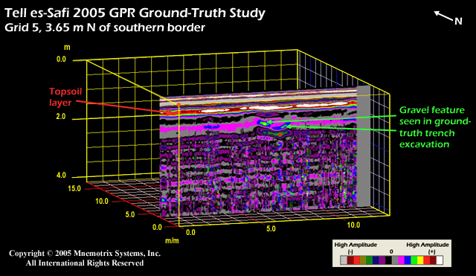
Figure 8: Slanted view of gravel feature and topsoil layer seen in ground-truth trench.

What is important about these GPR findings is the degree of clarity seen in the GPR feature in relation to the real slope of the gravel layer seen in the profile of Figure 7. The GPR data has yet to be adjusted for elevation, explaining the difference in slope between Figures 7 and 8.
Figure 9 is a merging of these two types of data, georeferenced to each other in ArcGIS by focusing on the gravel feature. This gravel stands out in the GPR data because it is significantly different from the surrounding chalk/marl matrix. The topsoil layer also is imaged well with GPR and corresponds to the sharp boundary that we saw in the field between the topsoil and chalk/limestone fill of the sub-surface.
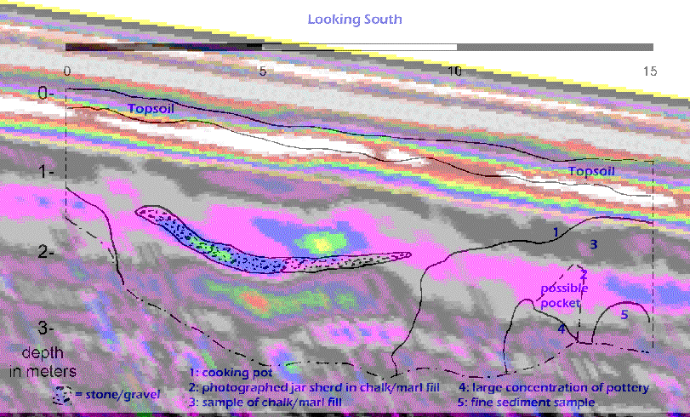
Figure 9: Merged GPR and Field Profile data, using ArcGIS. The gravel layer is seen particularly well in the GPR data, showing the success of GPR applications at Tell es-Safi to aid in strategic planning at the site.

The degree to which the sub-surface features are able to be accurately imaged, and the clarity and success of image matching in these two different kinds of site modeling confirms the efficacy of using GPR in a geoarchaeological application such as Tell es-Safi. One can clearly see the curve in the GPR anomaly that is traced in the profile, and see that it matched the shape which was seen visually by the crew during the ground truth excavation.
The GPR results have helped to increase our understanding of the sub-surface of this area of the Tell es-Safi excavation. We now have sufficient confirmation of results to recommend extending the line of the siege trench based on the anomalies found.
This is another example of using GPR as a strategic technique at a site where research and excavations will continue into future seasons. Plans are underway for GPR work to be continued near the excavated sections of the 2005 season to decide where is best to continue during the 2006 season, in addition to continued siege-trench investigations.

