Ground Penetrating Radar Survey Report:

2004 Tell es-Safi/Gath Archaeological Project

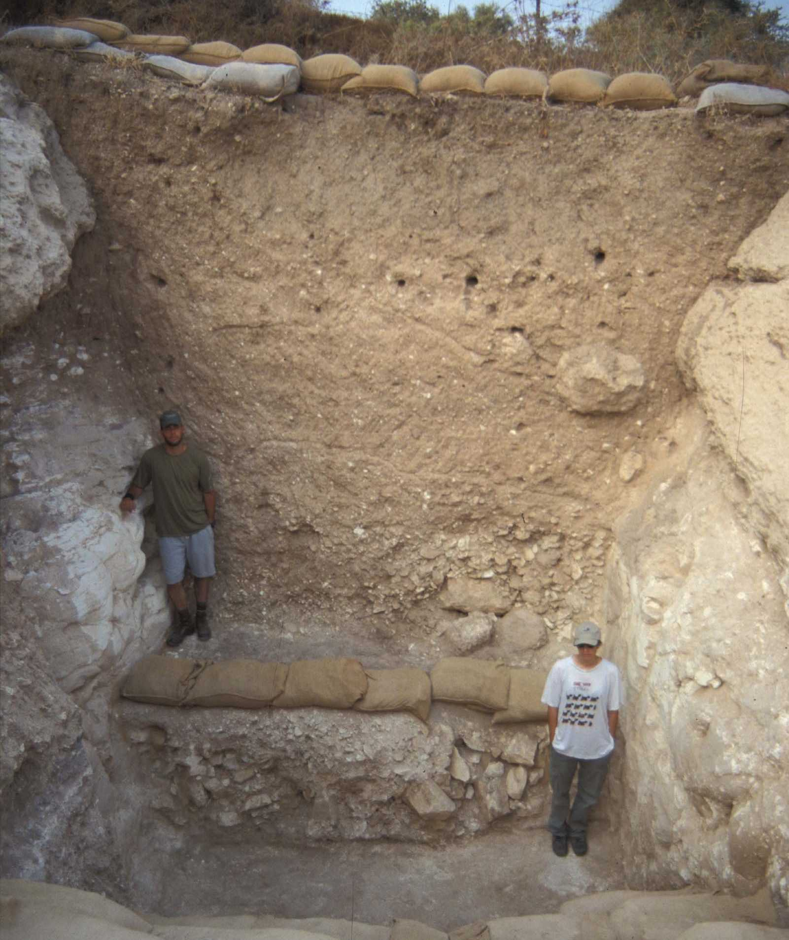

Figure 1: Excavated siege trench at Tell es-Safi.

Data Acquired July 13 – August 4, 2004

Report compiled November 10, 2004

Survey and Report Published by Mnemotrix Systems, Inc.
Chief GPR Surveyor, Jessie Pincus

Copyright © 2004 Mnemotrix Systems, Inc.
All International Rights Reserved

Background

In what may be one of the largest contiguous geo-archaeological Ground Penetrating Radar (GPR) studies completed to date, during the summer of 2004 Mnemotrix Systems, Inc. continued its 2003 GPR work at Tell es-Safi/Gath Archaeological project to further explore and locate remains of an ancient siege trench that may have led to the ultimate destruction of that phase of civilization during the mid-8th century BCE (Iron IIB). This trench is over 2 km long, and surrounds the site on the eastern, southern, and western sides. An area of about 75 square meters was surveyed in 11 contiguous separately acquired grids of parallel GPR transects in addition to a 12th Control Study grid close to the already excavated trench in Area C6. These grids were put together into a Super-3D grid which covers the side of the hill sloping down towards the current cultivated fields to the north.
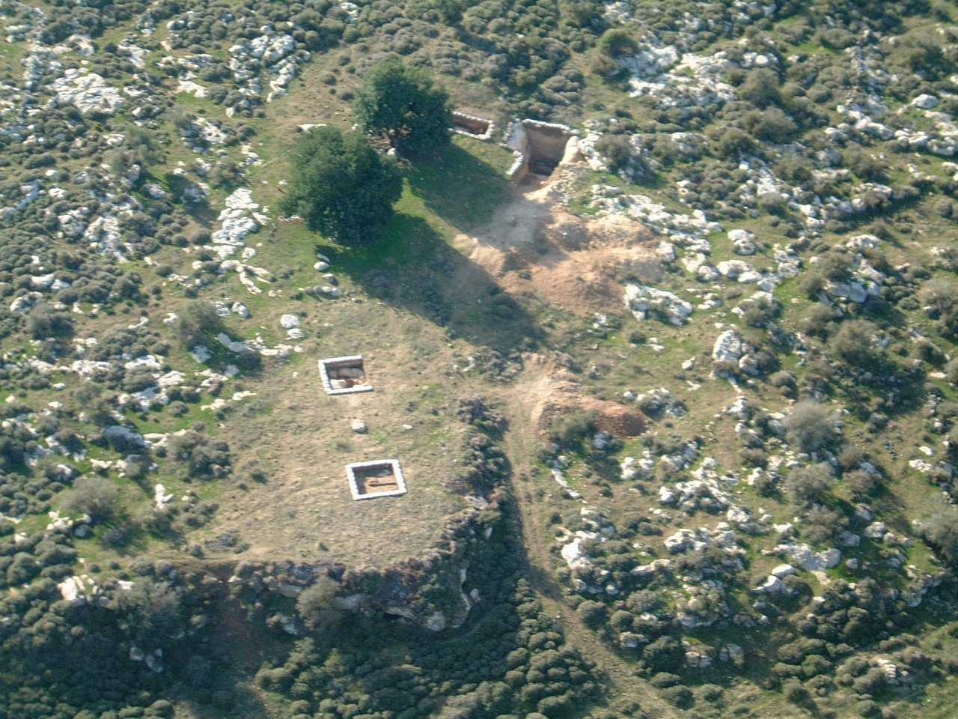

Figure 2: Aerial view of excavated siege trench at Tell es-Safi looking S-SW.
One of the largest archaeological sites in Israel, Tell es-Safi has vast unexplored resource areas for GPR since resources for excavation are limited. Having spent several days in the previous 2003 season, we determined that spending several weeks in the 2004 season might offer an opportunity to execute a GPR Study on this very large area, in the hopes of plotting the course of this siege trench of some considerable proportions.

Description of Survey Area
Tell es-Safi is named for its white chalk cliffs that can be seen from the road once entering the site. The terrain is rough for GPR with many limestone boulders present either in the form of old wall remains from historic villages or as bedrock that juts out from the surface to create the general landscape. Shale sediments are also present in the soil, making it hard for GPR to penetrate. The area that we chose to work in, following the guidance of Chief Archaeologist, Dr. Aren Maeir, forms an upward gradual slope as we head south but is rather steep close to Area C, as seen in Figures 2, 3, and 4.
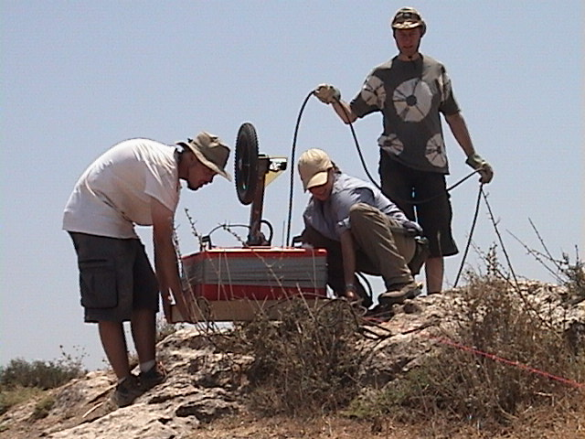
When we began, much of the site was covered by thorny bramble weeds. When acquiring GPR data, the ground-surface must be as flat and smooth as possible. Because of this, we became quite skilled in the art of removing these types of plants! All areas were cleared of brush before acquiring GPR data for that grid. As can be seen on the maps, there is a tremendous change of elevation across the 75 square meter area (see also Figure 3). Elevation points must be recorded and accounted for in the GPR data. This is a significant part of the project and is on-going. We hope to have this layer of elevation data available to us in the coming months. As of yet, however, this element has not been accounted for in the GPR data. More reference to this will come later in the report.
Figure 3: Managing the steep terrain at Tell es-Safi with our 200 MHz antenna.
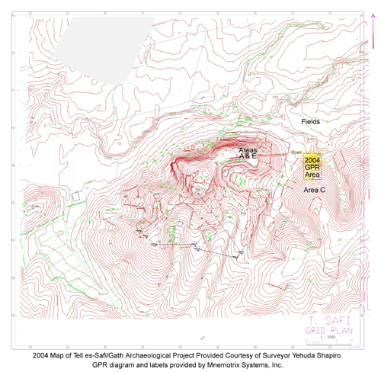
Figure 4: Bird’s eye view of Tell es-Safi and 2004 GPR work. A full-size version is available at: http://www.mnemotrix.com/geo/essafi/trench/zsite3.html.

Actions Taken
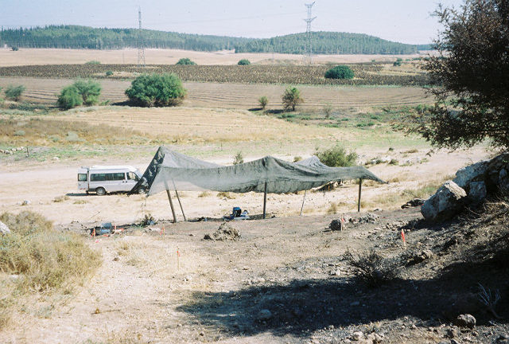
In beginning the 2004 GPR survey of Tell es-Safi, Dr. Maeir marked out a broad area (partial view seen in Figure 5) in which he believed the continuation of the siege trench may be based on the landscape and archaeological information available to him. We chose a point centrally located within this larger area and began work. Figure 6 is a map of the 2004 GPR Area that shows the placement of our GPR grid using a GPS device to record our corner points. GPS corner points of each grid and elevations can be found in Supplement A. Figure 8 is a schematic map of the GPR grids as we placed them on the ground on the tell. Please keep in mind the change in elevation and the 1-3 meter accuracy of a hand-held GPS device. This also explains the discrepancy that is visible when comparing the two maps.
Figure 5: Looking downhill north to the fields over surveyed area.
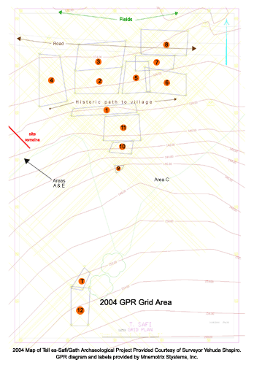
Geophysical Survey Systems, Inc. (GSSI) equipment was used to acquire all data this summer. We used a 200 MHz antenna,
Figure 6: Bird’s eye view of 2004 GPR Area. A full-size version is available at: http://www.mnemotrix.com/geo/essafi/trench/zsite5.html.
shallow profile, with a viewing
window of 150 ns aimed to “see” three to five meters below the surface along with a
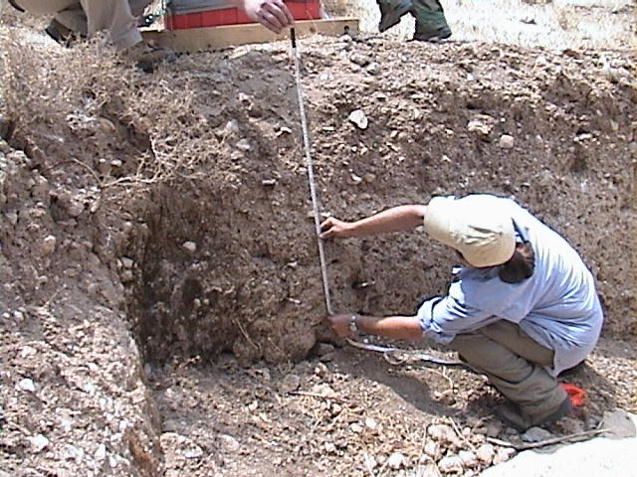
calibrated survey wheel to mark horizontal distance within each grid of each acquired GPR transect. Standard field methods were used including a guideline cord placed at equal distances along the edge boundaries of each grid to help the GPR surveyor pulling the antenna maintain the correct distance within the grid itself. GPR profile lines were acquired in north-south and east-west directions 1.0 to 1.5 meters
Figure 7: In-field depth analysis test near Grid 12 Trench Control Study.
apart depending on the chosen density
for each of the twelve grids. In addition, a velocity analysis test was performed in the field to correct for depth in the GPR data once the surveying was complete for use in post-processing (see Figure 7).

Post-Processing and Analysis
After each individual GPR transect was grouped according to grid, basic post-processing methods were applied to each transect. These included correcting the zero-position of the beginning wave into the sub-surface, filtering out high-frequency noise due to cellular phones and other environmental additions, and a slight smoothing of the data in order to better see the sub-surface features.
Each dataset/grid was then analyzed and key sub-surface features were noted in figures, which are discussed below. Maps and orientation figures were also created, including Figures 6, 8, and 9.
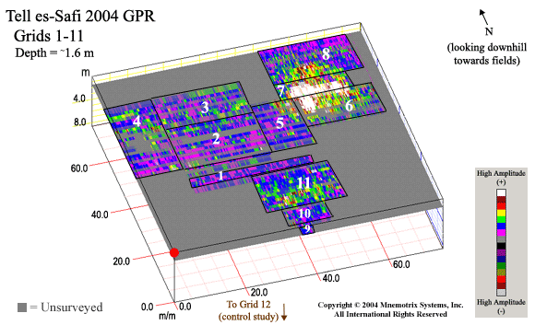

Figure 8: Schematic map of 2004 GPR Grids 1-11.

This GPR Map can be seen in a GIS format with hotlinks to the relevant grid area GPR studies at:

http://www.mnemotrix.com/geo/essafi/trench/trench.html

To aid in analysis and understanding of the sub-surface area of the trench study at Tell es-Safi, two animations of the full range of depth slices of the control study, Grid 12, where the trench has been excavated in previous seasons, and for Grids 9, 10, and 11, which covered the next accessible area extending down the steepest portion of the slope, were also created. Depth slices were acquired in both directions (N/S and E/W), and put into an interlocking 3D grid, near the area towards the hilltop where the siege trench had been excavated in previous seasons. These animations are available via the Internet on our website at:

Grid 12: http://www.mnemotrix.com/geo/essafi/trench/es04anm1.gif.
Grids 9, 10, and 11: http://www.mnemotrix.com/geo/essafi/trench/es04anm2.gif.

The anomalies seen in each of the grid areas are shown and discussed below. It is hoped
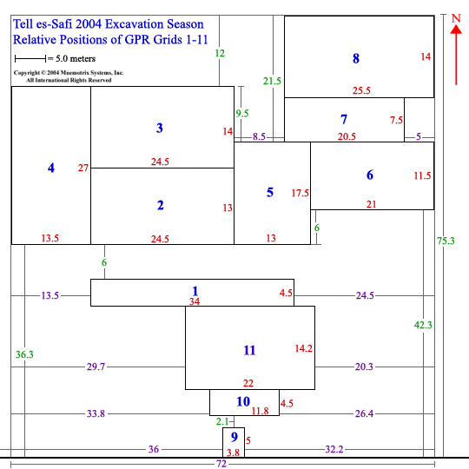

Figure 9: Positions of GPR Grids 1-11 relative to each other as laid out in the field.

that what appears to be a signature of the trench can be mapped to the archaeological field study at the site and assist in planning the work to be done in future seasons.
As mentioned above, Grid 12 was done as a control study at the end of the GPR Study. We had been surveying an approximately 75 square meter area down the hillside trying to plot the course of the trench. Grid 12 was an area at the top of the hill where the trench had been fully excavated in previous seasons. While the geology was somewhat different at the top of the hill, and while the excavation itself would alter the GPR results, we still believed we could get a sub-surface signature of the trench in an area where we knew it was located. In post-processing, we did find this signature to reappear in the areas where the trench seemed to be located. Figure 10 shows the probable trench signatures seen in the Control Study. As we analyzed the rest of the grids we looked for these types of signatures to locate remains of the ancient siege trench downslope from Area C.

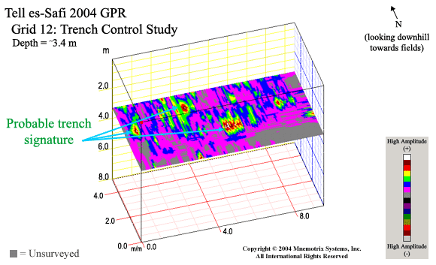
Figure 10: Probable trench signature seen in the Grid 12 Trench Control Study. These signatures were used as a base for analysis when studying the remaining grids as we worked north downslope from Area C.

Grids 1, 2, and 3 were the first grids acquired, in their numbered sequence. A view of the road and Similar Trench Signature is seen in Figure 11 below. Grid 1 was the first area chosen for accessibility in the middle of a very large general area laid out by Dr. Maeir based on many years of experience working at Tell es-Safi, and based on an educated "best guess" as to where the trench should lead. Transects were acquired in a somewhat coarse grid (every 1-2 meters) so as to cover as much ground as possible in a reasonable amount of time. The raised berm area lies to the east (at right of surveyed area).

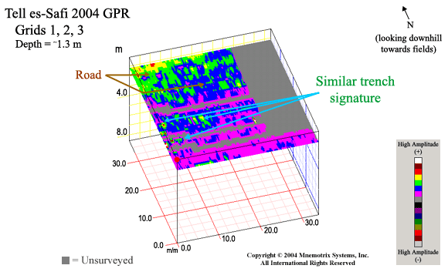

Figure 11: View of Grids 1, 2, and 3, showing the similar trench signature and road in the GPR data.

Grid 4 (Figure 12) marks the western border of the whole area surveyed using GPR in 2004. The areas surveyed in Grids 2 and 3 showed an anomaly of interest close to the western side. We wanted to see how far this extended, and thus marked out the area in Grid 4. The anomaly seemed to continue into this western area but then disappears, leaving us free to turn our attention to the east.
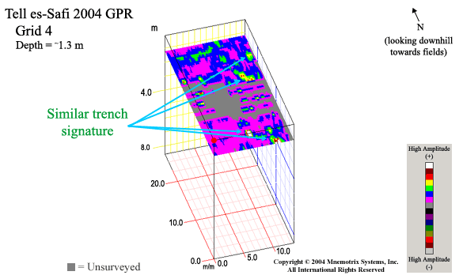
Figure 12: Grid 4 marks the western boundary of the 2004 GPR survey at Tell es-Safi. Similar trench signatures are labeled.

The area to the east of Grid 1, where the GPR trench exploration began, was our next stop as we tried to locate the trench. This became Grid 5 and is seen in Figure 13 below. We had seen an anomaly and had traced it in Grid 4 to its western disappearance. Now we needed to see what lay to the east as we approached the raised berm area. Note that at this time we have not yet made any allowances for changes in elevation in the bumpy terrain.

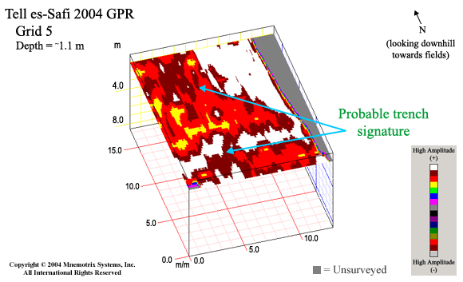
Figure 13: Probable trench signatures are labeled in Grid 5. The western edge of the berm is seen as the white area in the top right corner. Note that elevations have not been accounted for in this data.

Grid 6 encompassed the area around the berm and showed interesting anomalies of distinction which extended several meters in depth. Grid 6 was extended sufficiently to the east so that we could mark a clear end to these sub-surface features. It seemed clear that what we were looking for did not extend further to the east, but that it did extend further north, which led to our survey of grid areas 7 and 8. This can be seen in Figure 14 below.

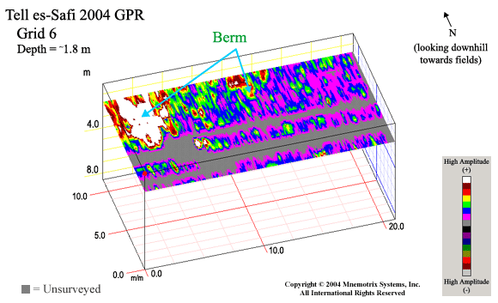
Figure 14: As we traced the trench downslope, we extended Grid 6 considerably to the east in order to see if there were any visible remains of the trench in this area. None were seen and so we continued further north of the berm. Elevations have not yet been accounted for in this data.

Grids 7 and 8 included the raised berm area, which would have been the area "behind" where the trench was being dug where the earth was piled up in the creation of the trench at that time. The area (Figure 15 below) showed the most distinct anomalies of the GPR survey, and extended several meters in depth. Note that elevation information of the bumpy topography has not yet been taken into account or factored in for correct depth notations throughout, which means the depth is an estimated "uniform" depth. In these areas we followed the sub-surface anomalies north and across the modern-day dirt road. While the trench signature seemed to disappear under the road, probably due to impacted soil conditions, it can be faintly seen again on the north side of the road. These signature points can be drawn in on the map to determine the course of the trench and plot its probable continued course beyond the surveyed area.

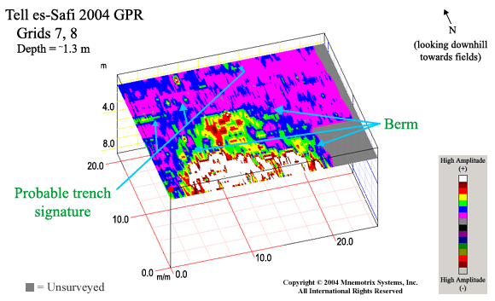
Figure 15: This area showed the most distinct GPR anomalies in the study, which were seen in the berm, as labeled here. Probable trench signatures were seen to the west of the trench, which supports the archaeological data of the berm being located behind the trench as it was the dug-out chunks of bedrock and soil that formed the natural geology of the area at the time.

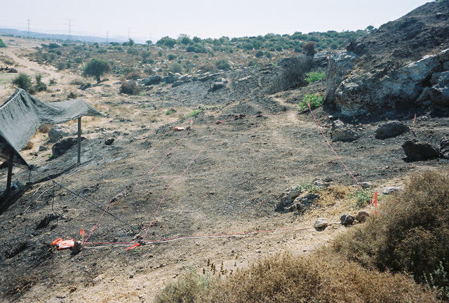
The next practical area beneath the hilltop where the siege trench had been excavated in previous seasons was chosen for Grids 9, 10, and 11 (see Figure 17 below). Areas 9 and 10 at the top of the hill towards the south were between boulders and barely accessible, but we were able to acquire some transects. This allowed for better plotting of the direction the trench seems to be taking as it wends its way down the hill. Grid 11 was steep but accessible (see Figure 16), so we were able to execute interlocking grids in both directions (E/W and N/S), which captured the signature of the trench in an effective, high resolution manner.
Figure 16: View of Grid 11 looking east on beginning of steep incline.

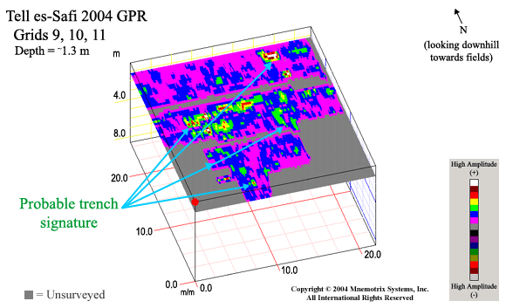
Figure 17: This area was located just north of Area C and was the closest we could come to the actual trench with the GPR equipment. Grids 9, 10, and 11 proceed from south to north with probable trench signatures labeled. Grid 9 was located between two boulders, thus its small size.

Conclusions

A fairly consistent anomaly can be seen and traced throughout the area, starting with the Grid 12 Control Study and working its way downslope north towards the fields. We studied the individual grids (which allows for higher 3D resolution) to locate what seemed to be a similar anomaly, or GPR "signature" denoting where the trench might be. We then plotted their location on the Super-3D GPR grid (Figure 19) using black dots.

The distance between the cluster of dots to the west and to the east is about 23 meters towards the middle of our survey area at a lower elevation, so it seems unlikely this distance could represent two sides of a siege trench. The berm area can be seen visually where noted to the east as a raised area, as that area has been left relatively undisturbed, while the area coming closer to the road and beyond it has been cleared, cultivated, and planted.
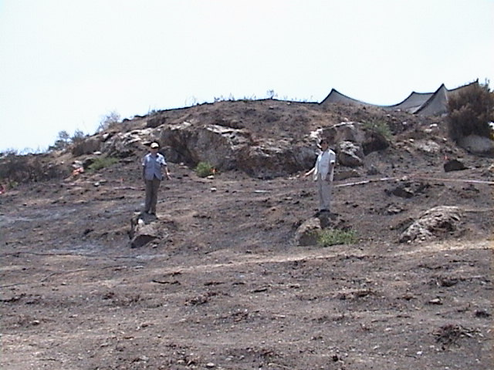
The area at the top of the hill (Grid 9) is located just beneath and north of the excavated trench area, and is between two boulder areas (see also Figure 18). According to Dr. Maeir, looking at the ancient and modern landscape, this section should
Figure 18: Marking sub-surface anomalies as we plot the course of the trench downslope. Boulders marked are in Grid 11 and seen as black line in Figure 19.
be directly in the
trench, with berm remnants to the east. Therefore it seems logical to connect the dots coming down the hill and veering to the east as shown. This can be seen in Figure 19 where black lines mark “probable course of the trench and berm”.

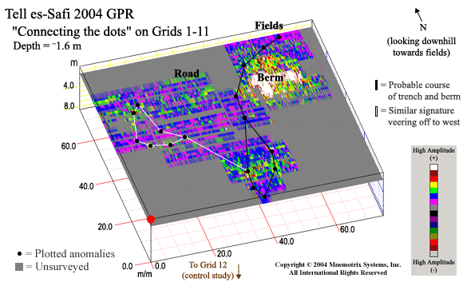
Figure 19: After studying the individual grids, we were able to plot the signatures labeled in each to trace the probable course of the trench and berm. A similar signature seemed to veer off to the west in Grids 2, 3, and 4. Ground truth excavation will be the key to understanding the true nature of these GPR anomalies.

The cluster of "dots", or similar GPR signature to the west, could indicate something from the same time period, or at least something which would leave the same trace on the sub-surface as would the trench. A follow-up ground truth study on both areas will shed light on this subject, perhaps next season.

Special Thanks
The Mnemotrix Systems Field Team would like to offer special thanks to Natan Tor, Isaac Kotlicky, Benjamin Shlomo, Johannes Näf, Rolf Zimmermann, Tommy Beyl, Dovid Kanarfogel, Adrian Grūnenwald, Eli Stieglitz, Ben Schwartz, and Gal Avraham who all helped to slave in the Judean sun with us to complete this intensive study of the siege trench at Tell es-Safi during the 2004 Excavation Season. We would also like to thank Dr. Aren Maeir, Yehuda Shapiro, Uri Reiss, and all the others we have forgotten to name, whose professional and logistical aid throughout the field season made this study possible.

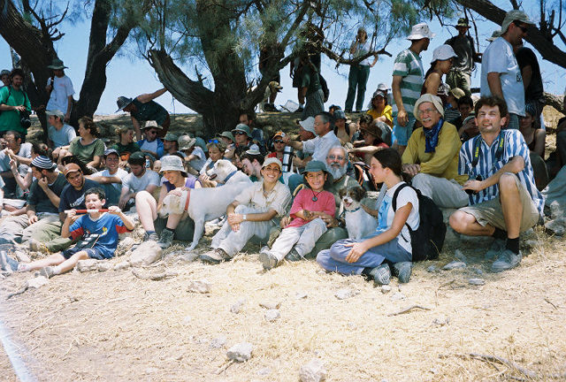

The 2004 Tell-es Safi/Gath Archaeological Project Crew!

Supplement A: GPS Grid Corner Points and Elevations
This information can also be seen at: http://www.mnemotrix.com/geo/essafi/trench/t_gps.html

GPS coordinates and elevations for GPR Survey Grids at the Tell es-Safi Study during the summer 2004 excavation season were acquired using a handheld Magellan GPS device, where precision is only available within a few meters. Accuracy for anomalies seen in GPR visualizations can also vary within the same degree. Elevation information as given here in meters (M) is available on the topographical site survey map, but has not been factored into the GPR depth slices at this time, and has not yet been acquired with sufficient accuracy to be input as such.

Archaeologist Area of Interest
Grid Corner | Israel Grid Coordinates | Elevation
A-SE | 186-426E, 623-530N | 139M
A-NE | 186-423E, 623-572N | 134M
A-NW | 186-340E, 623-564N | 134M
A-SW | 186-352E, 623-523N | 141M

GPR Survey Grid 1
Grid Corner | Israel Grid Coordinates | Elevation
1-SE | 186-387E, 623-525N | 139M
1-NE | 186-386E, 623-530N | 140M
1-NW | 186-353E, 623-527N | 140M
1-SW | 186-352E, 623-523N | 141M

GPR Survey Grid 2
Grid Corner | Israel Grid Coordinates | Elevation
2-SE | 186-377E, 623-535N | 137M
2-NE | 186-379E, 623-549N | 137M
2-NW | 186-354E, 623-547N | 137M
2-SW | 186-354E, 623-535N | 138M

GPR Survey Grid 3
Grid Corner | Israel Grid Coordinates | Elevation
3-SE | 186-379E, 623-549N | 137M
3-NE | 186-381E, 623-563N | 136M
3-NW | 186-356E, 623-561N | 134M
3-SW | 186-354E, 623-547N | 137M

GPR Survey Grid 4
Grid Corner | Israel Grid Coordinates | Elevation
4-SE | 186-350E, 623-531N | 132M
4-NE | 186-346E, 623-555N | 136M
4-NW | 186-335E, 623-556N | 121M
4-SW | 186-335E, 623-528N | 134M

GPR Survey Grid 5
Grid Corner | Israel Grid Coordinates | Elevation
5-SE | 186-379E, 623-535N | 139M
5-NE | 186-381E, 623-552N | 137M
5-NW | 186-393E, 623-552N | 139M
5-SW | 186-394E, 623-536N | 139M

GPR Survey Grid 6
Grid Corner | Israel Grid Coordinates | Elevation
6-SE | 186-413E, 623-534N | 137M
6-NE | 186-413E, 623-545N | 138M
6-NW | 186-391E, 623-549N | 137M
6-SW | 186-392E, 623-536N | 136M

GPR Survey Grid 7
Grid Corner | Israel Grid Coordinates | Elevation
7-SE | 186-406E, 623-548N | 133M
7-NE | 186-407E, 623-555N | 132M
7-NW | 186-386E, 623-555N | 130M
7-SW | 186-386E, 623-547N | 131M

GPR Survey Grid 8
Grid Corner | Israel Grid Coordinates | Elevation
8-SE | 186-413E, 623-555N | 134M
8-NE | 186-414E, 623-568N | 133M
8-NW | 186-389E, 623-569N | 133M
8-SW | 186-389E, 623-556N | 134M

GPR Survey Grid 9
Grid Corner | Israel Grid Coordinates | Elevation
9-SE | 186-379E, 623-495N | 135M
9-NE | 186-380E, 623-497N | 133M
9-NW | 186-375E, 623-497N | 131M
9-SW | 186-376E, 623-493N | 135M

GPR Survey Grid 10
Grid Corner | Israel Grid Coordinates | Elevation
10-SE | 186-384E, 623-503N | 135M
10-NE | 186-385E, 623-510N | 136M
10-NW | 186-374E, 623-509N | 137M
10-SW | 186-372E, 623-504N | 135M

GPR Survey Grid 11
Grid Corner | Israel Grid Coordinates | Elevation
11-SE | 186-389E, 623-510N | 139M
11-NE | 186-388E, 623-524N | 137M
11-NW | 186-370E, 623-523N | 137M
11-SW | 186-369E, 623-510N | 138M

GPR Survey Grid 12
Grid Corner | Israel Grid Coordinates | Elevation
12-SE | 186-361E, 623-412N | 159M
12-NE | 186-362E, 623-432N | 153M
12-NW | 186-352E, 623-433N | 151M
12-SW | 186-352E, 623-412N | 153M

Previously Excavated Siege Trench
Grid Corner | Israel Grid Coordinates | Elevation
T-SE | 186-358E, 623-431N | 150M
T-NE | 186-362E, 623-440N | 149M
T-NW | 186-359E, 623-443N | 149M
T-SW | 186-352E, 623-432N | 147M

