Ground Penetrating Radar Survey Report:

One Miami Pre-Construction, Miami, Florida
Historic Royal Palm Hotel Courtyard

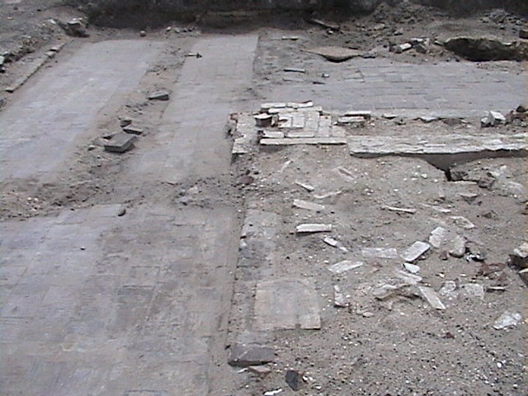

Data Acquired March 31, 2004

Report compiled April 14, 2004

Survey and Report Published by Mnemotrix Systems, Inc.

Copyright © 2004 Mnemotrix Systems, Inc.
All International Rights Reserved

Introduction
One Miami is a site located on the northern bank of the Miami River across from the Miami Circle in downtown Miami, Florida. The site is currently undergoing archaeological investigation in the pre-construction phase of future construction at the site. Robert S. Carr, Executive Director of the Archaeological and Historical Conservancy, Inc., heads the archaeological excavations here.
The site of One Miami has been sub-divided into three areas, Parcel B, C, and D. Ground Penetrating Radar was applied to Parcel D in April, 2003, which Mnemotrix Systems, Inc. staff assisted on. When a need surfaced again in Spring 2004, Bob Carr asked Mnemotrix to again assist. Therefore Mnemotrix undertook a GPR survey in another portion of Parcel D on March 31, 2004, towards the goals of delimiting the foundations of the Historic Royal Palm Hotel which had already been excavated just weeks before the GPR survey was done, as well as determining if there might be additional indications that human remains might be located in the area.

Actions Taken
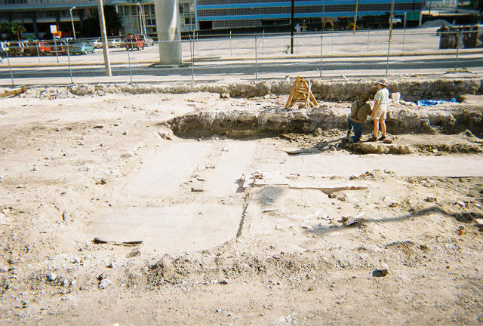
As mentioned above, Parcel D had already been undergoing excavation along its southern end. A portion of those excavations can be seen in the photo to the left looking south. This view shows the courtyard which had been unearthed as part of the Royal Palm Hotel wing.
Human remains which predated the 19th Century hotel’s construction from much more ancient burials, had recently been excavated from this area of the site and were expected to continue to be found beneath the fill to the north. After discussions with Mr. Carr, it was decided to do a GPR survey of the area that was next to be opened for excavation, and as of yet, had only had its asphalt removed. The aim was to transect the wing of the hotel to see what it looks like and how far to the north it extends. Below is a portion of the area north of the excavated area that was the main area of interest in the GPR survey. It shows the fill from the backhoe work that was being done at the time of the March GPR survey.
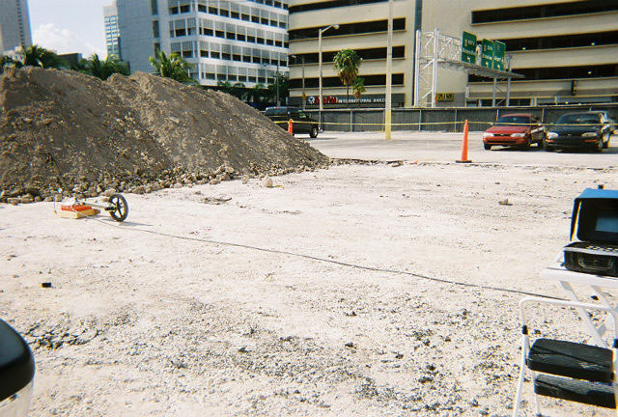
According to evidence visible in the excavation pits, about the top 0.75 meters was fill consisting of sand, limestone pebbles, silt, soil, and metal objects such as nails or screws. A profile of the excavations can be seen in the picture below. We were told that the foundations of the hotel began around 0.80 meters below the surface.
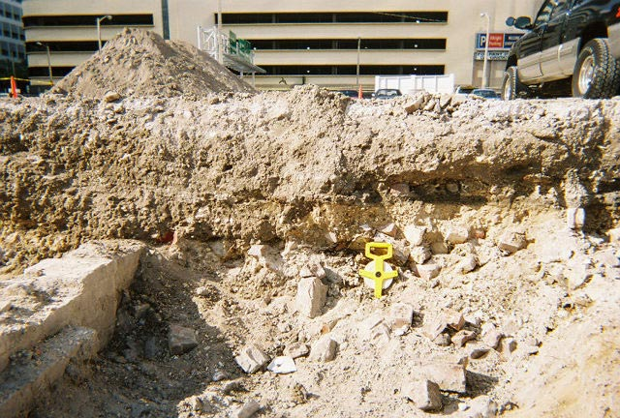
We decided to execute three grids, the first two combining in a cross-grid to form the southern study, and the third grid becoming the northern study.
- Dataset 1 was 21 x 4m wide running in an E/W direction parallel to the existing excavations.
- Dataset 2 was a 4 x 4m square grid which transected a subset of the E/W Dataset I above, running in a N/S direction directly opposite where the human remains had been found. This smaller grid was flush with the excavations, 1 meter closer to the edge than Dataset I.
- Dataset 3 was a 17.5 x 10m grid running in an E/W direction parallel to the existing excavations, yet further north. It was in this section where we hoped to find the end of the hotel wing, which we hoped would show in the GPR study as a repeated feature similar to what was coming up in Dataset I.

The placement of these GPR grids can be seen more clearly on the map on page 7 of this report.

Dataset 1 and 2 (Southern Grid Area)
A 400 MHz antenna (with a 60 nanosecond pulse range) was chosen for all GPR work at this time. This setup was chosen in order to have very high resolution at a relatively shallow depth of 1-3 meters below the surface. The survey lines were tightly spaced, 20 cm apart.
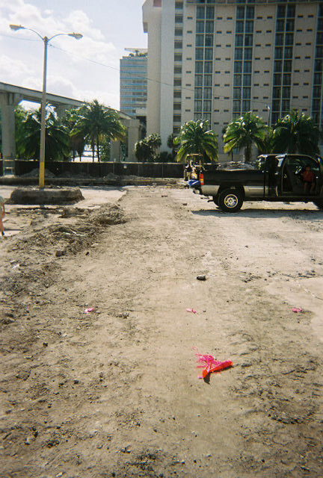
Within the grid, which was marked out in the dimensions of 21 meters (East-West) by 4 meters (North-South), GPR signal data was acquired in a tight set of 21 overlapping parallel lines taken first East to West, and then transected by 20 lines in a perpendicular direction North to South subset grid (Dataset 2). Dataset 2 was located from 3.5 – 7.5 meters along Dataset 1.
These perpendicular sets of data were put together into a 3D cube for follow-up study in a post-processing environment.
Dataset 3 (Northern Grid Area)
The same 400 MHz shallow (60 ns window) antenna and profile were used for the northern grid, which was undertaken to determine how far the hotel wing extended and to ascertain an idea of how much further excavation would be wise to determine the location of more human remains and archaeological relics.
Dimensions of the surveyed area were 10.0 meters (North-South) by 17.5 meters (East-West). As different from the southern grid where a tight intensive study of the area was done, the survey lines acquired were only required to be spaced every 50 cm rather than every 20 cm.
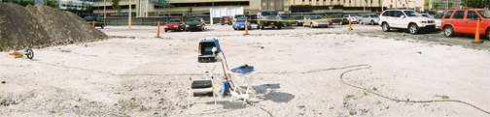
During post-processing, the GPR signal data collected for the southern area was analyzed closely as to depth (vertical axis) and movement along the horizontal axis in a 3D cube.

Visualization and Analysis
An in-depth visualization of the anomalies found in this March 2004 survey can be seen in an animated explanation on the Mnemotrix website at this address: http://www.mnemotrix.com/geo/1miami/1m_anim.html. If you are connected to the Internet while reading this report, you can view this animation by clicking above.

As the vertical depth slices proceed from the surface down to a depth of approximately 2.25 meters, many of the features labeled in the map below can be seen in 5.0 cm increments from the surface. The map below labels and explains features seen in the animation, available also at http://www.mnemotrix.com/geo/1miami/1m_map1.html.

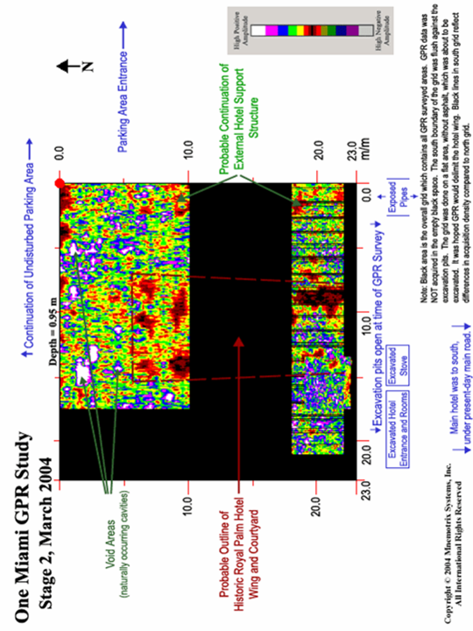
Because of the interest in the human remains, the subset grid depth analysis directly north of the archaeological human remains was done. Features within this area are labeled in the map below and can be traced in the animation following it.
See: http://www.mnemotrix.com/geo/1miami/1miami2.html

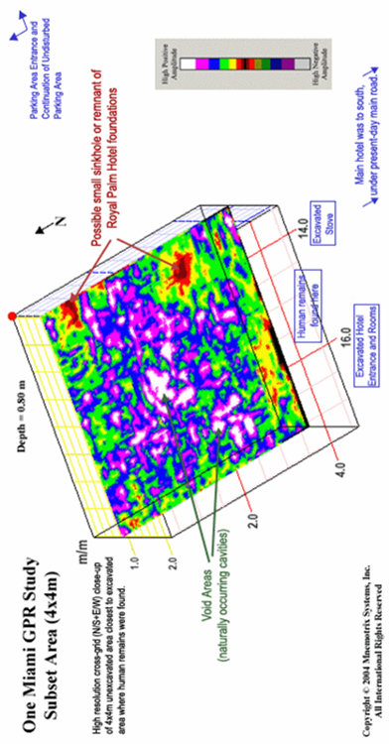
As can be seen in the vertical depth profiles and as combined with the maps, there are several features that became evident in the GPR survey. The historic Royal Palm Hotel wing and courtyard extends to ~14 meters north of the excavations at the time of the survey. Before post-processing, and while in the field, we walked out the area to see where these reflections were showing up. As we walked it out going south towards the excavation, they lined up right along either side of the courtyard already excavated. Due to their homogenous nature typical of concrete or brick, we expect to find similar hotel foundations in the ground-truth excavations of the GPR grid.
It is here important to note that high positive amplitude colors on the GPR maps and depth profiles signify a strong reflection of the material, while low positive amplitude colors signify a weak reflection in the surrounding material or matrix. Each positive amplitude color has a reciprocal negative amplitude color, and can be seen in the color table shown here. Low positive and negative amplitude colors also signify an object or feature of homogenous material such as a large area of brick, concrete, or soil. Where colors of white, magenta, or blue are present, there exists a strong difference between layers of sub-surface material, which can be viewed as an anomaly.
In speaking with Bob Carr about the site, we know that the Paleo-Indians who used this area for burial chose places where there were natural sinkholes or voids in the limestone bedrock. It is here that they would place their dead and grave goods. As indicated in the GPR maps, numerous void areas seem to be prevalent in the area and as they often are the places of burials (according to Bob Carr), would therefore be good places to expect to find human remains. Good depths to keep in mind for ground-truth excavation in the NW corner of the North grid would be around 0.90 and 1.55 meters.
When working out the accurate distance measurements of our acquired GPR data, as compared with our measured grid, and as compared with the grid information given to us by the archaeological team, we estimated that our placement of features could be accurate within a plus or minus accuracy of about 70 cm (less than 1 meter) horizontally. Depth calculations appear fairly precise based on comparison to visible layers in excavated areas.

Summary and Recommendations:
Since the One Miami Construction project has been reported to be on a tight time frame, this data should be useful as to where to excavate and provide a more efficient use of time spent. Based on what is hoped to be found concerning the old hotel wing, it should now be easier to delimit where to find its end point. The areas of voids especially north of the north end of the hotel wing are quite large, and coincide with archaeological reports that bodies had been moved in that general direction before the original hotel was built. These void areas would be good candidates for finding relics and perhaps more human remains.
If the broader area of the construction site needs to be fully excavated, then more GPR should be done to speed up the process of where to look, since clearly this process enhances the view of what can be expected.

